Genealogy for Kids  Grades K-2  Introduce your students to the basics of genealogy in this hands-on workshop. Students will have the opportunity to construct their own family trees using age-appropriate materials. Students will learn key genealogy terms such as maternal, paternal, generation, ancestor, and lineage.  This program can be expanded to include oral history interviewing skills and/or family heirloom show-and-tell.  Standards: K.1.1, K.1.3, K.3.6, 1.1.1, 2.1.2  Weather Watchers  Grades 1-3  Recording and predicting weather patterns has historically been an important part of people’s lives. In this program, students will learn about how weather affected the outcome of some key events in history – even the rise and fall of some cultures! Students will have the opportunity to examine 100-year-old daily weather logs from Syracuse, summarize local weather trends over the last century, and make their own weather journals for daily observations.  Standards: 1.3.5, 3.3.11  * Other state standards may be addressed in subjects of Science, Music, and/or Math. |  |  | Natural Resources  Grades 1-4  Our area has always had a rich abundance of natural resources. In this program, students will learn about those resources, how they have been exploited in the past and present, and what’s being done to manage and conserve our remaining resources in a responsible manner.  Standards: 1.3.9, 1.4.5, 2.4.1, 2.4.2, 3.1.3, 3.1.8, 3.3.12, 3.3.13, 3.4.1, 4.3.5, 4.3.6, 4.3.7, 4.3.8  Mapping Kosciusko County  Grades: 1– 5  Why are maps important? Students will learn the basic features of maps and their importance in our past and present lives. This program will reinforce basic map-reading skills such as compass rose, latitude-longitude, scale, and map symbols using a variety of historical maps of Kosciusko County and Turkey Creek Township. Students will examine how land use has changed in the local community and generate their own local maps!  Standards: 1.3.1, 1.3.7, 2.1.2, 2.3.1, 2.3.3, 2.3.4, 2.3.5, 2.3.7, 3.1.6, 3.3.8, 3.3.11, 4.3.1, 4.3.2, 5.3.1, 5.3.4  **While these topics have certain grades and standards attached to them, if you feel the topic fits in with your curriculum, please discuss with me what you would like to do.  I am open to making a subject simpler for a younger group, or a bit more advanced for an older group. |  |  | SYracuse-Wawasee historical museum  - Educational Classroom Outreach Programs  - 2015

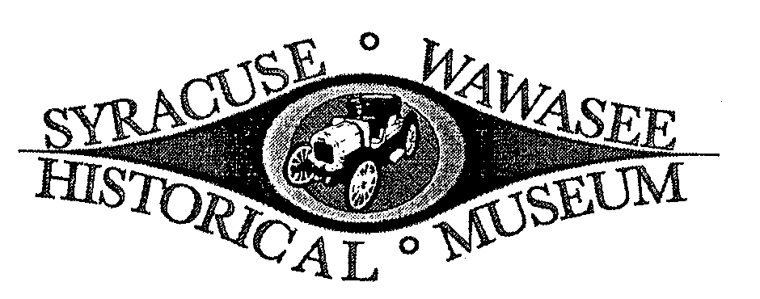  General Information:  The Syracuse-Wawasee Historical Museum has a mission of sharing local history with all members of the community – including school children! Our outreach programs aim to excite students about our town and county history through hands-on activities and interdisciplinary learning. All programs are tied to Indiana State Core Standards for Social Studies and can be tailored to emphasize specific learning objectives or topics at the request of classroom teachers.  Outreach programs are designed to be held in school classrooms, or may also take place on site at the Museum. Museum tours and scavenger hunts for children are also available by request. Programs are free; donations are appreciated. Some program expansions may require a small fee per student for supply costs.  Contact Information:  Jamie Clemons, Director  Syracuse-Wawasee Historical Museum  1013 North Long Drive  Syracuse, IN 46567  574-457-3599  director@syracusemuseum.org  www.syracusemuseum.org |  |  | Prehistoric Indians  Grades: 3 – 5  Using artifacts found right here in Kosciusko County, students will learn about the prehistory of Indiana as understood through archaeological findings. Students will find out about and distinguish between the Paleo-Indian, Archaic, and Woodland eras of Native history. Students will have the opportunity to identify a collection of projectile points using a dichotomous key and make a true-to-scale time line of major Indian eras.  Standards: 3.1.1, 3.1.6, 4.1.1, 5.1.1  Historic Native Americans  Grades: K – 5  Using maps, models, and hands-on activities, students will investigate Native American culture by comparing various tribes that occupied Kosciusko County during the 18th and 19th centuries. Students will learn about food, clothing, shelter, and recreational activities of these Native Americans and hear traditional Miami Indian stories. This program can be expanded to include the retelling of Native American stories through student-created artwork, or an exploration of various Native American cultures throughout the United States.  Standards: K.1.1, K.1.3, 1.1.1, 1.1.2, 1.1.9, 2.1.2, 2.3.5, 3.1.1, 3.1.6, 4.1.2, 5.1.3, 5.1.6, 5.3.4  *Other state standards may be addressed in subjects of Science, Music, and/or Math. |  |  | Citizens of Syracuse  Grades 1-4  How did Syracuse get started? Students will learn about Syracuse’s founding fathers and other prominent citizens of Syracuse’s early years, including Samuel Crosson, J.P. Dolan, Eli Lilly, George Miles, and W.E. Long. Students will work with both primary and secondary sources as they examine old photos, letters, journals, newspaper articles, and historical artifacts to gain a better understanding of Syracuse’s past.  *This program can also be adapted for a living history museum program to be held at the museum. Children will choose a citizen, dress as the citizen, and give a speech as that citizen to members of the community walking through for the program.  Standards: 1.1.2, 1.1.9, 2.1.1, 2.1.2, 2.1.3, 2.1.5, 2.1.7, 3.1.2, 3.1.6, 4.1.11, 4.4.7  Life of a Pioneer Child  Grades K – 2  How was a pioneer child’s day different from a typical child today? Students will learn about children’s chores, lessons, and recreational activities of 100+ years ago. Students can try their hand at making butter, “washing” clothes, and/or playing pioneer games.  Standards: K.1.1, 1.1.1, 1.1.2, 1.1.9, 2.1.2

